GUJRAT TECHNOLOGICAL UNIVERSITY
Chandkheda, Ahmedabad




L. D. COLLEGE OF ENGINEERING
A PROJECT REPORT ON

DRIVER ANTI SLEEP DEVICE
UNDER PROJECT OF DESIGN ENGINEERING –2B BE SEMESTER – 6TH

(ELECTRONICS & COMMUNICATION ENGINEERING)

SR.  NO. | NAME OF STUDENT | ENROLLMENT NO
1 | AJIT KULKARNI | 220283111001
2 | ARJUN CHANGLA | 220283111004
3 | MOHAMMAD FURKAN | 220283111013
4 | KEVAL VARA | 220283111043

GUIDE: - Prof. KINNAR VAGHELA H.O.D.: Dr. C.H. VITHALANI

ACKNOWLEDGEMENT

The success and final outcome of this project required a lot of guidance and assistance from many people and I am extremely privileged to have got this all along the competition along of our project. All that we have done is only due to such supervision and assistance and I would not forget to thank them.

I respect and thank of our guide Prof. KINNAR VAGHELA…for providing us an opportunity to do the project work in (L. D. COLLEGE OF ENGINEERING, AHEMDABAD) and giving us all support and guidance for complete the project. I am extremely thankful to him for providing such a nice support and guidance, also he had busy schedule managing the corporate affairs.

I am thankful to and fortunate enough to get constant encouragement, support and guidance from all teaching staff of mechanical department which helped us in successfully completing our project work. Also I would like to extend our sincere esteems to all staffs in laboratory for timely support.

Project associates

- AJIT KULKARNI
- ARJUN CHANGLA
- MOHAMMAD FURKAN
- KEVAL VARA
INDEX

Sr. No. | Topic | Page No.
1 | Abstract | 01
2 | Introduction | 02
3 | AEIOU Summary | 03
4 | Mind mapping canvas | 06
5 | Empathy canvas | 08
6 | Ideation Canvas | 11
7 | Product Development Canvas | 13
8 | Learning Needs Matrix | 16
9 | Components and model photos | 18
10 | Prototyping and component cost | 21
11 | Future scope | 22
12 | References | 23
13 | Logbook | 24

ABSTRACT

Feeling sleepy or drowsy while driving could cause hazardous traffic accident. However, when driving alone on highway or driving over a long period of time, drivers are inclined to feel bored and sleepy, or even fall asleep. Nowadays most of the products of driver anti-sleep detection sold in the market are simply earphone making Intermittent noises, which is quite annoying and inefficient . As such there is a high demand for cheap and efficient driver sleep detection. Therefore, we came up with an idea and underdeveloped a sleepy detection and alarming system which could effectively meet this demand.

1

INTRODUCTION

Project motivation and purpose is to develop a system that can accurately detect sleepy driving and make alarms accordingly. Which aims to prevent the drivers from drowsy. Driving and create a safer driving environment. The project was accomplished by a Webcam that constantly takes image of driver. A beagel board that implement image processing algorithm of sleepy detection and a feedback circuit that could generate alarm and a power supply system.

This system has many features that make it unique and functional. Features includes, Eye extraction use open and close to determine sleepiness, Daytime and night detection, Real time image processing and detection , Sound and flashing LED warning system to redraw driver’s attention , Little interference and potential hazard to drivers normal driving , Portable size with car cigarette charger socket power supply.

This project emerges at the intersection of robotics and home maintenance, aiming to create a device that not only simplifies the cleaning process but also enhances its effectiveness. Traditional mopping methods often entail manual labor and repetitive motions, which can be both laborious and time-consuming. By leveraging the capabilities of robotics and remote-control technology, our aim is to introduce a novel approach that automates and optimizes the mopping task, ultimately providing users with more leisure time and a cleaner living environment.

Through this report, we will delve into the various aspects of our project, from its conceptualization and design to the implementation and testing phases. We will discuss the underlying technologies utilized in the development of the driver anti-sleep device, including sensors, actuators, and control systems. Additionally, we will explore the considerations considered during the design process, such as maneuverability, adaptability to different zone surfaces, and user interface design.

Ultimately, our endeavor seeks to offer not just a technical solution but a practical and transformative tool that addresses the evolving needs of modern automotive cars . By introducing a driver anti sleep-device, we aim to contribute to the ongoing discourse on smart car technologies while making a tangible difference in the everyday lives of users.

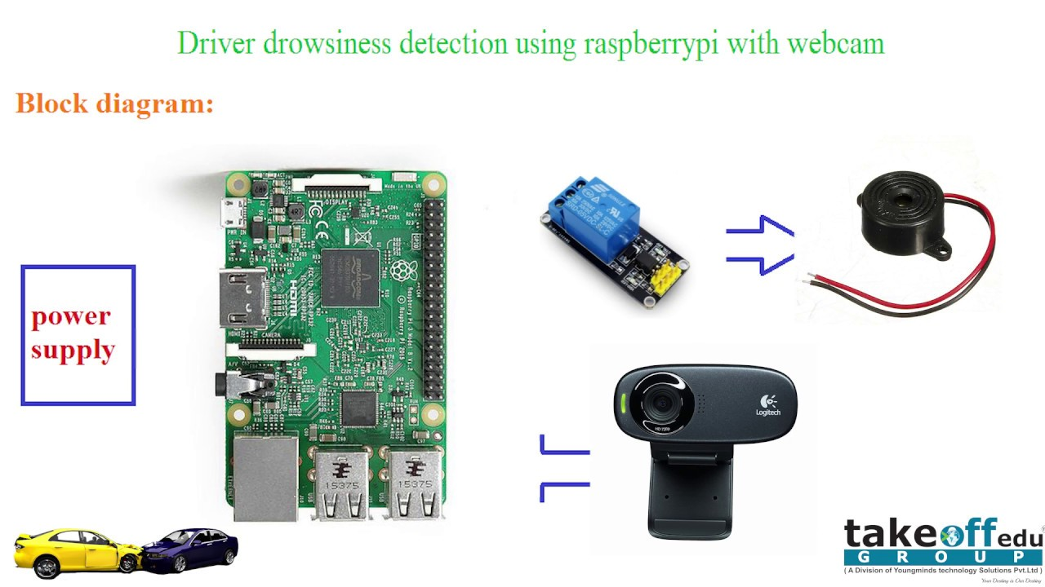

AEIOU Summary

The AEIOU summary canvas contains 5 Sections: 1.) Activity
2.) Environment
3.) Interaction
4.) Object
5.) User

1.) ACTIVITY:
- Driving for car
- Working in machine
- Pilots
- Locomotive pilots
- Brainstorming.

2.) ENVIRONMENT:
- Early morning
- Hilly regions
- Late night
- Day time

3.) INTERACTION:
- Student Engineer
- Student Drivers
- Student Workers
- Student Causal labour

4.) OBJECTS:
- Arduino
- Webcam
- Sensors
- Buzzers
- Relays
- Circuits

5.) USERS:
- Four wheelers
- Industrial area
- Domestic sector
- Locomotive driver
- Pilots

MIND MAPPING CANVAS

1.) ACTIVITY
- Driving for car
- Working in machine
- Pilots
- Locomotive pilots
- Brainstorming.

2.) Benefits
    - Faster operation
    - Life saving
    - Collateral damage saving
    - Reduce life risk

3.) equipment
- Arduino
- Webcam
- Sensors
- Buzzers
- Relays
- Circuits

5.) driving mechanism
    - Conversion from viewing eye sensor to electrical signal
    - actuate alarm
6.) application
- Four wheelers
- Industrial area
- Domestic sector
- Locomotive driver
- Pilots

EMPATHY CANVAS

Empathy mapping canvas contain 4 sections:
1.) User
2.) Stakeholders
3.) Activity
4.) Story Boarding
1.) USERS:
- Drivers
- Engineers
- Labours

2.) STAKEHOLDERS:
    - Car manufacturer
    - machines manufacturer
    - government

3.) ACTIVITIES:
- Driving for car
- Working in machine
- Pilots
- Locomotive pilots
- Brainstorming.

4.) STORY BOARDING

      - HAPPY
Consider Sarah, a working mother who tries to keep up with housework while earning for her children, mopping the floor frequently takes a backseat, leaving her concerned about spills and sailed appearance.
    - HAPPY
With help of remote-control mopping machine, mrunal can now clean dirt under furniture and corner with comfort of her couch while his son plays. Now she has more time for relax and play with her children during cleaning the home.

    - SAD
Consider an old men named Arthur who lives alone. He takes care to keeping his home, but he bends down to wipe the floors which is very difficult for him.

    - SAD
Mohan’s present housekeeping staff leaves the floor moist and slick which makes him concerned about falling. Mohan is looking for a solution to keep his home tidy without jeopardizing his safety. Remote-control mopping machine could be solution for his problem.

IDEATION CANVAS

Ideation canvas contain 4 sections: 1.) People
2.) Activities
3.) Situation/Context/Location
4.) Props/Possible Solution

1.) PEOPLES:
- Drivers
- Engineers
- Pilots
- Locomotive drivers
2.) ACTIVITIES:
- Driving for car
- Working in machine
- Pilots
- Locomotive pilots
- Brainstorming.

3.) SITUATION/CONTEXT/LOCATION:
    - Daily cleaning / remove dust & foreign particles / Residential area
    - Cleaning larger floor/ time saving / industry or factory
    - Cleaning platforms/ less human effort / railway station

4.) PROPSIBLE:
  - Mobile operated mopping machine.
  - Remote control mopping machine.
  - Floor scrubber dryer machine.

11

PRODUCT DEVLOPMENT CANVAS

- PEOPLES:
- Drivers
- Engineers
- Pilots
- Locomotive drivers

- PURPOSE:
    - Faster operation
    - Life saving
    - Collateral damage saving
    - Reduce life risk

3.) PRODUCT FUNCTION:
- system that can accurately detect sleepy driving and make alarms accordingly. Which aims to prevent the drivers from drowsy. Driving and create a safer driving environment. The project was accomplished by a Webcam that constantly takes image of driver. A beagel board that implement image processing algorithm of sleepy detection and a feedback circuit that could generate alarm and a power supply system.

4.) PRODUCT FEATURES:
- Drivers
- Engineers
- Labours

5.) COMPONENTS:
- Arduino
- Webcam
- Sensors
- Buzzers
- Relays
- Circuits

6.) CUSTOMER REVALIDATION:
- Requie less efforts in cleaningNo leakage of water
- Easily dryer than manual mopping

7.) REJECT, REDISGN, RETAIN:

- Retain

LEARNING NEEDS MATRIX

- TOOLS/METHODS/THEORIES/APPLICATION PROCESS INVOLVED
  - Flow regulator
  - Motorized wheel for motion
  - Conversion from electrical energy to mechanical energy.

- SOFTWARE/SIMULATION/SKILLS/MATHEMATICALREQUIRMENTS
  - Solid-works
  - ANASY
  - Tinder CAD

- COMPONENT/MATERIALS/STRENGTH CRITERIA (EXPLORATION-VARIETIES/TESTING REQUIREMENTS
  - Scrubbing pad – plastic mesh
  - Circuit – copper & silicon
  - Cleaning efficiency test
  - Remote control test
  - Visual inspection

- APPLICABL STANDARDS AND SPECIFICATIONS/ PRINCIPLES AND EXPERIMENTS
  - Geometric dimensioning and tolerance
  - Iso 677: 1976
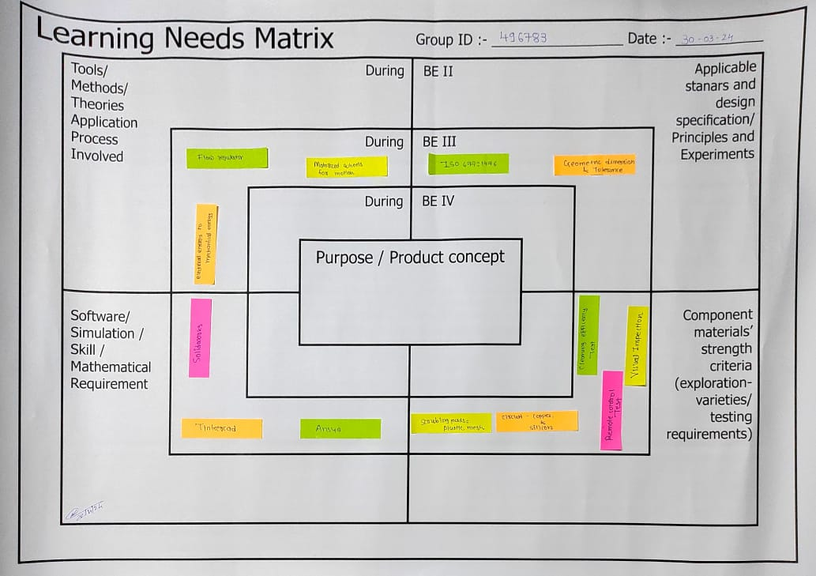

MAIN COMPONENETS

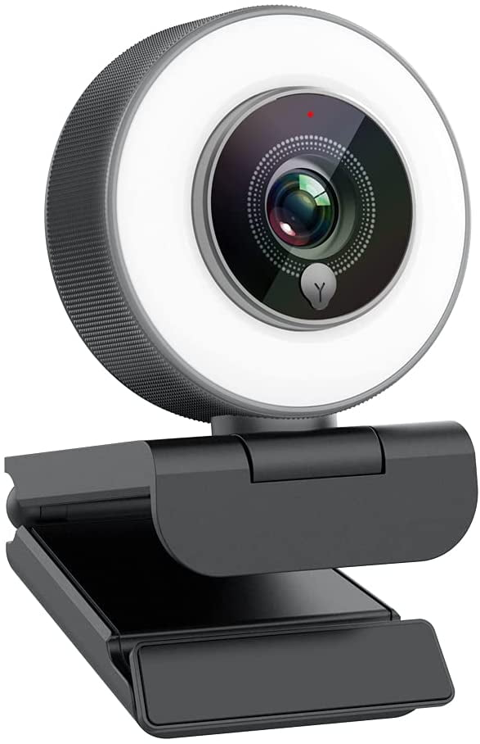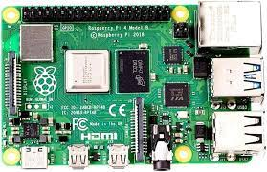

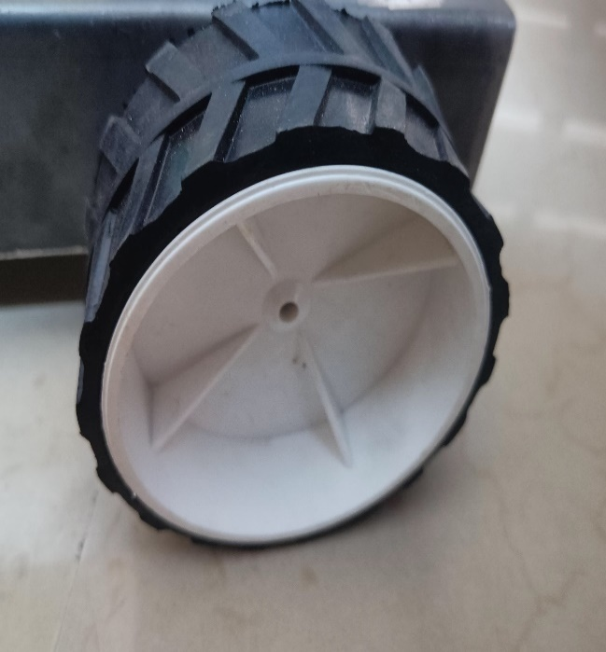
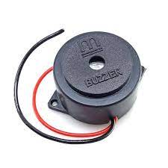

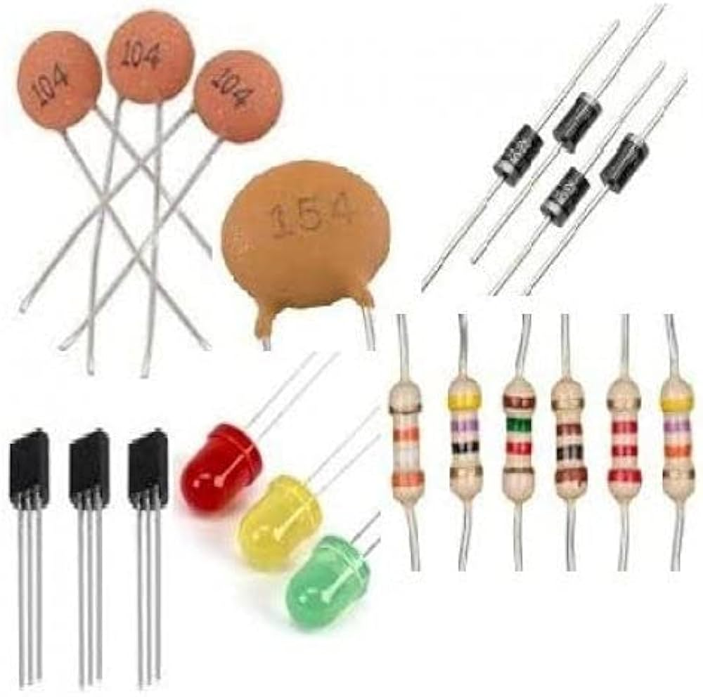

CAD model and working prototype

PROTOTYPING

Our product is to develop a system that can accurately detect sleepy driving and make alarms accordingly. Which aims to prevent the drivers from drowsy. Driving and create a safer driving environment. The project was accomplished by a Webcam that constantly takes image of driver. A beagel board that implement image processing algorithm of sleepy detection and a feedback circuit that could generate alarm and a power supply system.

This system has many features that make it unique and functional. Features includes, Eye extraction use open and close to determine sleepiness, Daytime and night detection, Real time image processing and detection , Sound and flashing LED warning system to redraw driver’s attention , Little interference and potential hazard to drivers normal driving , Portable size with car cigarette charger socket power supply.

- COMPONENT COST
NO. | COMPONENT NAME | QUANTITY | UNIT PRICE | PRICE (INR)
1 | Raspberry pi | 1 | 4500 | 4500
2. | webcam | 1 | 500 | 500
3. | buzzer | 1 | 60 | 60
4. | relays | 2 | 60 | 120
5. | Wheels | 4 | 25 | 100
6. | Battery cell (3.7v & 2000mah) | 2 | 40 | 80
7. | I R sensor | 1 | 25 | 25
8. | Battery cell socket | 1 | 25 | 25
9. | Base plate | 1 | 20 | 20
10. | Wire | 2 meters | 25/meter | 50

FUTURE SCOPE

.
- Make the user and vehicle safe. Betterment to life. In future the project implementation will be more accurate and more research and trail take place.
- scope of driver anti sleep device holds considerable potential for revolutionizing automative car and commercial working place practices. As technology continues to advance, these machines are poised to become more sophisticated, efficient, and accessible. One avenue of development lies in the integration of artificial intelligence and machine learning algorithms, enabling mopping machines to adapt to different floor surfaces, adjust cleaning patterns based on usage trends, and even autonomously navigate complex environments. Additionally, advancements in sensor technology could enhance the machines' ability to detect and avoid obstacles, prevent collisions, and ensure thorough cleaning coverage.

- The proliferation of smart home ecosystems presents opportunities for remote driver anti sleep device to seamlessly integrate with other connected devices, allowing for centralized control and automation. Furthermore, improvements in battery technology could extend operating times and reduce charging intervals, enhancing overall productivity and user convenience. With growing emphasis on sustainability, future iterations of these machines may prioritize eco-friendly cleaning solutions and materials, minimizing environmental impact.

REFERENCES

[1]
“CT-1205CL-SMT Buzzer.”
Retrieved from
http://www.digikey.com/product-detail/en/CT-1205CL-SMT/102-1267-1ND/610975.
[2]
“XM7 USB port Data sheet.”
Retrieved from
http://www.digikey.com/product-detail/en/XM7A-0442A/OR1070-
ND/2755612
[3]
“TPS61032 (ACTIVE) 5-V Output, 1-A, 96% Efficient Boost Converter.” Texas

Instruments, Jan 2012. http://www.ti.com/lit/ds/slus534e/slus534e.pdf.
[4]
“LM 2679-5.0 (ACTIVE) 5-V Output, 5-A, 96% Efficient Buck Converter.” Texas
Instruments, Jan 2012. http://www.ti.com/lit/ds/symlink/lm2679.pdf.
[4] “IEEE Code of Ethics”
Retrieved from http://www.ieee.org/about/corporate/governance/p7-8.html
PROJECT: DRIVER ANTI SLEEP DEVICE
TEAM ID: 511414

LOGBOOK

Date | Task Description
19/01/2024 | Selection of Problem, Causes of Problem
02/02/2024 | Prior Art of Solving this Problem Concept
09/02/2024 | Concept of solving this problem
16/02/2023 | List of different components
01/03/2024 | Gathering Knowledge Components
15/03/2024 | Design of Solution Model
22/03/2023 | Gathering limitations of project
05/04/2024 | Cost Comparison between  different Solution available in the market versus our project
12/04/2024 | Preparation of Documents

